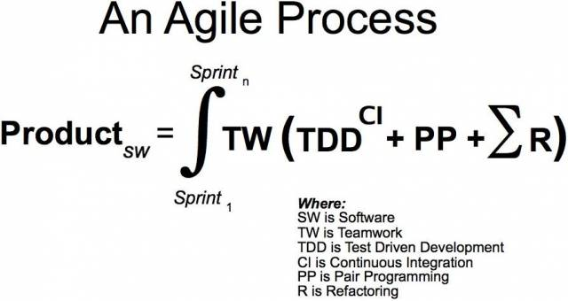Jump to Smartgram Wiki Main Page
Agile Menifesto We are uncovering better ways of developing software by doing it and helping others do it.
Through this work we have come to value:
Individuals and interactions over processes and tools
(개개인과 상호 작용/소통을 프로세스와 도구보다)
Working software over comprehensive documentation
(제대로 동작하는 소프트웨어를 폭넓은 문서보다)
Customer collaboration over contract negotiation
(고객과의 협력을 계약 협상보다)
Responding to change over following a plan.
(변화에 대응하는 것을 계획을 준수하는 것보다 더 가치있게 여긴다.)
That is, while there is value in the items on the right, we value the items on the left more.

